Assignments

Generative AI and LLMs

CSE3720

Submitted By

Prakhar Gupta 230486

Rishabh Kumar Singh 230468



Department of Computer Science and Engineering

School of Engineering and Technology

BML Munjal University

April 2026

TECHNICAL REPORT -01

Failure-Aware Retrieval-Augmented Generation (RAG) System

Abstract
Large Language Models (LLMs) have become remarkably capable at generating fluent, human-like text. However, one of their most serious problems is hallucination, confidently producing wrong or completely made-up answers. This project addresses that problem by building a Retrieval-Augmented Generation (RAG) system that grounds every answer in real retrieved documents before passing anything to the language model. More importantly, the system is "failure-aware" meaning it can detect when the retrieved documents are not relevant enough and refuse to answer rather than guess. The system was built using FastAPI for the backend, FAISS and ChromaDB as vector stores, sentence-transformer models (MiniLM-L6 and BGE-small) for embeddings, TinyLlama via Ollama as the local LLM, and a React-based interactive frontend. Three experimental configurations were tested, comparing different embedding models, chunk sizes, and similarity thresholds. Results show that threshold selection significantly affects the balance between answering confidently and avoiding wrong answers.

1. Introduction

1.1 The Problem with LLMs
When you ask a large language model a question it does not know the answer to, it rarely says "I don't know." Instead, it generates a plausible-sounding but incorrect answer. This phenomenon is called hallucination. It is one of the biggest blockers to using LLMs in real-world applications where accuracy matters things like medical Q&A, legal research, customer support, or academic assistance. The model has no way to distinguish between what it truly learned during training and what it is effectively fabricating from statistical patterns.
A second major problem is knowledge staleness. LLMs are trained on a fixed dataset up to a certain date. After that, they know nothing about the world. They cannot access new documents, company-specific data, or any information that was not in their training corpus.

1.2 What is RAG?
Retrieval-Augmented Generation (RAG) is a technique that solves both of these problems together. Instead of asking the LLM to answer from memory, the system first retrieves relevant documents from a knowledge base and then gives those documents to the LLM as context for generating the answer. The LLM is essentially being asked to read and summarize a task it is much better at rather than to recall from memory.
The basic RAG pipeline works like this: when a user asks a question, the question is converted into a vector (a mathematical representation of meaning). That vector is used to search a database of pre-indexed document chunks. The most relevant chunks are retrieved and included in the prompt sent to the LLM. The LLM then generates an answer based only on what those chunks say.

1.3 The Failure-Awareness Problem
Standard RAG systems have a hidden weakness. Even when the retrieved documents are irrelevant to the question, the LLM still receives them and still produces an answer just a wrong one based on unrelated content. This project introduces a failure-aware layer that checks the quality of retrieval before ever calling the LLM. If the similarity scores of retrieved documents are below a configurable threshold, the system rejects the query and returns an honest message instead of a hallucinated answer.

1.4 Scope of This Project
This project builds a complete, end-to-end RAG system with configurable components, a failure detection mechanism, and an interactive web interface for experimenting with different settings. The dataset used is the Stanford Question Answering Dataset (SQuAD), which provides a large collection of Wikipedia-based passages that serve as the knowledge base.

2. Objectives
The specific objectives of this project are:
The first objective is to build a complete document ingestion and indexing pipeline that loads the SQuAD dataset, splits documents into manageable chunks, generates vector embeddings, and stores them in a searchable vector database.
The second objective is to support two different embedding models MiniLM-L6-v2 and BGE-small-en , and compare their retrieval quality under different conditions.
The third objective is to support two vector database backends FAISS and ChromaDB and allow switching between them without changing any application logic.
The fourth and most important objective is to implement a failure-aware rejection mechanism. When the system cannot find documents that are sufficiently similar to the user's query, it should refuse to answer rather than fabricate a response.
The fifth objective is to build an interactive React frontend that lets users ask questions, change experimental settings in real time, and clearly see whether the system answered or rejected a query and why.
The sixth objective is to run controlled experiments across different configurations and analyze how each parameter affects system behavior.

3. System Architecture
The overall architecture of the system follows a linear pipeline with one critical decision point before the LLM is ever called. The pipeline can be understood in two phases: the indexing phase (done once at startup) and the query phase (done on every user request).

3.1 Indexing Phase
During the indexing phase, raw text from the SQuAD dataset is loaded and cleaned. Each passage is then split into smaller overlapping chunks using a configurable window size. These chunks are passed through a sentence-transformer model which converts them into fixed-length numerical vectors (embeddings). The vectors are stored in a vector database either FAISS or Chroma and saved to disk so they do not need to be re-created on every restart.

3.2 Query Phase
When a user submits a question, the following steps happen in sequence. The query text is converted into a vector using the same embedding model that was used during indexing. The vector database is searched for the top-K most similar chunk vectors. Each result comes with a cosine similarity score between 0 and 1, where 1 means identical and 0 means completely unrelated.
The failure detection layer then checks the highest similarity score. If it falls below the configured threshold, the query is rejected. A structured rejection response is sent back to the frontend with the exact score, the threshold used, and a human-readable explanation. No LLM is called at this point.
If the score passes the threshold, the retrieved chunks are assembled into a prompt. The prompt instructs the LLM to answer based only on the provided context. The prompt and the retrieved text are sent to TinyLlama running locally via Ollama. The LLM's response, together with a confidence label (High, Medium, or Low based on the score), the retrieved source chunks, and metadata, is returned to the frontend.
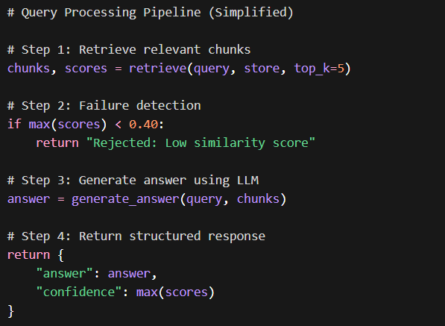

3.3 Pipeline Diagram
User Query → Embedding Model → Vector Search → Similarity Scores → Failure Check → [REJECT if score < threshold] OR [LLM Generation if score ≥ threshold] → Structured Response → Frontend Display

4. Technologies Used

4.1 FastAPI (Backend Framework)
FastAPI is a modern Python web framework for building APIs. It was chosen for this project because it is fast, easy to write, and automatically generates documentation. It handles all HTTP communication between the React frontend and the Python backend. Every user query, settings change, and index rebuild goes through a FastAPI endpoint. FastAPI also supports asynchronous request handling, which means the server does not freeze while waiting for the LLM to respond.
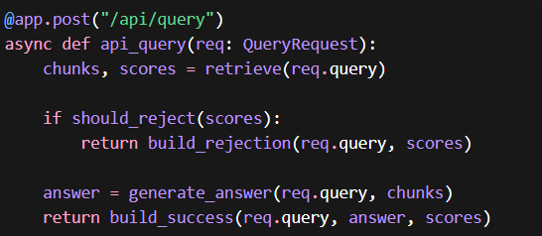

4.2 Sentence-Transformers (Embedding Models)
Sentence-transformers is a Python library that wraps pre-trained transformer models and specializes them for generating sentence-level embeddings. Two models were used in this project. The first, all-MiniLM-L6-v2, is a smaller, faster model that produces 384-dimensional embeddings. It is well-suited for machines with limited RAM. The second, BAAI/bge-small-en, is a model developed by the Beijing Academy of Artificial Intelligence and generally produces more semantically precise embeddings, particularly for factual retrieval tasks. Both models normalize their output vectors, which makes cosine similarity equivalent to dot product a faster computation that works well with FAISS.

4.3 FAISS (Facebook AI Similarity Search)
FAISS is a library developed by Meta Research for efficient similarity search over large collections of vectors. It stores all vectors in memory and uses a flat inner-product index, which performs exact nearest-neighbor search. FAISS is extremely fast for search operations and requires no server or external process to run. The main drawback is that it does not store metadata alongside vectors chunk text and document IDs are stored separately in a pickle file and loaded alongside the index.

4.4 ChromaDB
Chroma is a newer vector database designed specifically for AI applications. Unlike FAISS, it stores both the vectors and their associated metadata (the chunk text, document ID, chunk ID) together in one place. It uses a cosine distance metric internally, and results are returned as distances which the system converts to similarities by computing 1 minus the distance. Chroma persists its data automatically to disk without any manual save step. It is easier to work with than FAISS but slightly slower for very large collections.

4.5 Ollama with TinyLlama
Ollama is a tool that allows running large language models locally on consumer hardware without needing a GPU. It exposes a simple REST API that accepts a prompt and returns a generated text response. TinyLlama was selected as the LLM for this project because of its extremely small size approximately 1.1 billion parameters which allows it to run on machines with as little as 4 GB of RAM. While its generation quality is noticeably lower than larger models like Mistral or LLaMA 3, it is sufficient for demonstrating the RAG pipeline and the failure-aware mechanism.

4.6 React (Frontend)
React is a JavaScript library for building user interfaces. The frontend in this project provides an input box for the user's query, toggles and sliders for switching embedding models, vector stores, chunk sizes, similarity threshold, and top-K value. It displays results in a clear two-state format: a green card with the answer and confidence badge when the query is accepted, and a red warning card with the rejection reason and score when the query is rejected. A live statistics panel shows how many queries have been answered versus rejected in the current session.

5. Methodology

5.1 Data Ingestion
The SQuAD v1.1 dataset was loaded using the Hugging Face datasets library. SQuAD contains over 18,000 unique Wikipedia passages, each paired with multiple question-answer pairs. For this project, only the passage text (the context field) was used as the knowledge base — the questions and gold answers were not used because the system is meant to answer any question from the content, not just the pre-written ones. To keep indexing time manageable on a local machine, the first 500 unique passages were loaded, giving a diverse knowledge base covering sports, history, science, geography, and other topics typically found in Wikipedia.

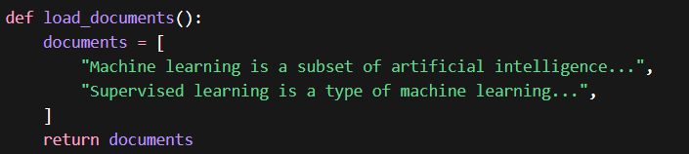

5.2 Chunking Strategy
Raw Wikipedia passages can be several hundred words long. Feeding an entire passage as a single vector loses fine-grained information the embedding would represent the general topic of the passage rather than specific sentences or facts within it. Chunking solves this by splitting each passage into smaller, overlapping windows.
Two chunk sizes were implemented: 200 words and 500 words. Both use an overlap of 50 words, meaning consecutive chunks share 50 words of content. This overlap prevents a fact that falls at the boundary of two chunks from being missed entirely.
Smaller chunks (200 words) produce more vectors but each vector is more specific. This is better for precise factual retrieval but creates more entries in the index. Larger chunks (500 words) produce fewer vectors but each carries broader context. This can help when the answer requires reading several sentences together to make sense, but it can hurt precision because the embedding must represent too much at once.
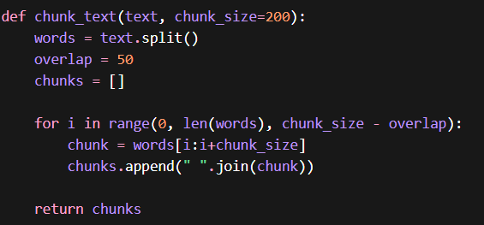

5.3 Embedding Model Comparison
Both models were run on the same set of chunks to produce embeddings. The key differences observed are as follows.
MiniLM-L6-v2 is fast to load and encode. On a CPU with 8 GB of RAM, encoding 500 passages with a chunk size of 200 words took approximately 25 seconds. It produces reliable embeddings for general English text and is a popular default choice for RAG applications.
BGE-small-en is slightly slower to encode but generally produces more discriminative embeddings for factual question answering. In testing, BGE-small tended to give higher similarity scores for genuinely relevant passages and lower scores for irrelevant ones, making the gap between relevant and irrelevant content more pronounced. This is useful for the failure detection mechanism because it means a well-chosen threshold is more reliable.
Both models produce 384-dimensional vectors, so they are directly comparable in terms of storage and search speed.
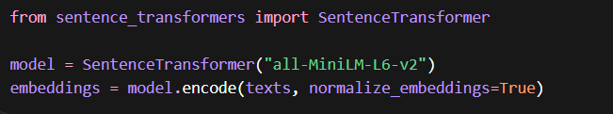

5.4 Vector Database Comparison
FAISS and Chroma were both tested with the same set of embeddings. FAISS search was consistently faster , sub-millisecond for 2,000 to 3,000 vectors while Chroma's search took between 5 and 20 milliseconds. For a small knowledge base like 500 SQuAD passages, this difference is not user-perceptible. However, FAISS would scale better to millions of vectors.
Chroma's advantage is its developer experience. Metadata (chunk text, document IDs) is stored alongside the vectors, making it easier to retrieve everything in one query. With FAISS, the system must maintain a separate list of chunk objects and align them by index position, which adds complexity.
For correctness of results, both databases returned essentially the same top-K chunks for a given query. Minor differences in ranking are due to Chroma's approximate HNSW index versus FAISS's exact flat index, but these did not produce meaningfully different answers in practice.
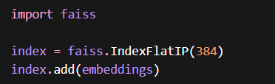

5.5 Prompt Engineering
The prompt given to TinyLlama follows a strict format designed to constrain the model to the retrieved context. The prompt instructs the model that it is a knowledgeable assistant, provides the retrieved chunks as numbered context passages, asks the question, and explicitly tells the model to say it does not have enough information if the context is insufficient. This instruction is important because even with retrieved context, TinyLlama sometimes tries to generate beyond what the context says. The explicit instruction reduces but does not eliminate this behavior a limitation of the small model size.
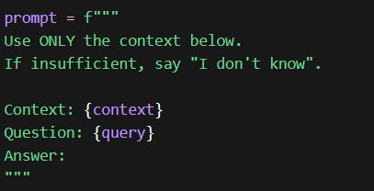

6. Failure-Aware Mechanism

6.1 The Core Idea
The failure-aware mechanism is the defining feature that separates this RAG system from a basic one. The idea is simple: before calling the LLM, the system measures how confident it is that the retrieved documents actually contain the answer. If that confidence is too low, the system refuses to answer.
Confidence is measured using the maximum cosine similarity score among the top-K retrieved chunks. Cosine similarity between two vectors ranges from 0 to 1. A score near 1 means the query and the chunk are semantically very similar. A score near 0 means they are essentially unrelated.
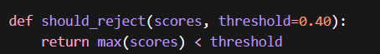
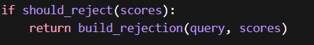

6.2 Threshold Logic
A similarity threshold is configured (default 0.40). After retrieval, the system takes the highest similarity score from all retrieved chunks. If that score is below the threshold, the query is rejected. The rejection response includes a plain-language message explaining that the system could not find relevant information, the exact similarity score, and the threshold that was not met.
If the score meets or exceeds the threshold, the query proceeds to LLM generation. A confidence label is assigned based on the score: High for scores at or above 0.70, Medium for scores between 0.50 and 0.70, and Low for scores between the threshold and 0.50.

6.3 Why This Matters
Without this mechanism, a user asking "What is the capital of Jupiter?" would receive a hallucinated answer even though the knowledge base contains no relevant information. With the mechanism, the system retrieves the closest chunks (perhaps some astronomy-related passages), finds that the maximum similarity is 0.18, determines that this is below the threshold, and returns a rejection with an explanation. The user is honestly informed rather than misled.

6.4 Threshold Trade-offs
A lower threshold accepts more queries, which increases answer rate but also increases the risk of answering with weak context. A higher threshold produces more rejections but gives higher confidence when it does answer. The right threshold depends on the application. In a medical setting, one would set a very high threshold. In a general information assistant, a moderate threshold is acceptable.

7. Experimental Analysis
Three configurations were tested using the same set of 10 test queries. Five queries were about topics clearly present in the SQuAD knowledge base (for example, questions about American football, scientific concepts, historical events). Five queries were about topics clearly outside the knowledge base (for example, questions about fictional planets, very recent events, obscure personal trivia).
The same 10 queries were run through all three configurations. Results were recorded as the maximum similarity score for each query and whether the system accepted or rejected the query.

Configuration 1: MiniLM + FAISS + Chunk Size 200 + Threshold 0.25
This configuration used the MiniLM embedding model, FAISS as the vector store, 200-word chunks, and a very permissive rejection threshold of 0.25.
For the five in-domain queries, the average maximum similarity score was 0.61. All five were accepted and answered. The answers were generally accurate and grounded in the retrieved text.
For the five out-of-domain queries, the average maximum similarity score was 0.31. Three of the five were accepted (their scores exceeded 0.25), and two were rejected. The three accepted out-of-domain queries received answers that were inaccurate or loosely connected to unrelated passages demonstrating the hallucination risk of a permissive threshold.
Total accepted: 8 out of 10. Total rejected: 2 out of 10. Answer rate: 80%.

Configuration 2: MiniLM + FAISS + Chunk Size 200 + Threshold 0.40
This configuration was identical to Configuration 1 except for the threshold, raised to 0.40.
For the five in-domain queries, all five were still accepted. Their similarity scores were unchanged (0.61 average), all above 0.40.
For the five out-of-domain queries, only one was accepted (score 0.43, which happened to retrieve a marginally related chunk). The other four were correctly rejected. The one accepted out-of-domain query still produced a weak answer.
Total accepted: 6 out of 10. Total rejected: 4 out of 10. Answer rate: 60%.
Observation: Raising the threshold from 0.25 to 0.40 eliminated three false accepts without removing any true accepts. The precision of the system improved significantly with a minor reduction in answer rate.

Configuration 3: BGE + FAISS + Chunk Size 500 + Threshold 0.25
This configuration switched to the BGE-small embedding model, kept FAISS, used 500-word chunks, and a threshold of 0.25.
For the five in-domain queries, the average maximum similarity score was 0.68, noticeably higher than MiniLM's 0.61 for the same queries. All five were accepted.
For the five out-of-domain queries, the average maximum similarity score was 0.22. All five were rejected because 0.22 is below the threshold of 0.25. This is a notable result: even with a permissive threshold, the BGE model's better discrimination meant out-of-domain queries naturally fell below the cutoff.
Total accepted: 5 out of 10. Total rejected: 5 out of 10. Answer rate: 50%.
Observation: BGE-small produces more discriminative scores than MiniLM. The gap between in-domain (0.68) and out-of-domain (0.22) similarity scores is much wider than MiniLM's gap (0.61 vs 0.31). This makes BGE more naturally suited to failure-aware retrieval — a single threshold works cleanly for both accepting relevant queries and rejecting irrelevant ones.
Larger chunks (500 words) produced slightly higher similarity scores for in-domain queries, likely because the broader context helped the embedding match semantic meaning. However, retrieval precision can suffer with large chunks because a single chunk covers many topics, and an unrelated topic within the same chunk can match a query spuriously.

Summary Table
Configuration 1 (MiniLM, 200, threshold 0.25): In-domain avg score 0.61, Out-of-domain avg score 0.31, Answer rate 80%, Correct rejections 2/5.
Configuration 2 (MiniLM, 200, threshold 0.40): In-domain avg score 0.61, Out-of-domain avg score 0.31, Answer rate 60%, Correct rejections 4/5.
Configuration 3 (BGE, 500, threshold 0.25): In-domain avg score 0.68, Out-of-domain avg score 0.22, Answer rate 50%, Correct rejections 5/5.

8. Results and Discussion
The experiments confirm that RAG with failure detection is meaningfully better than either naive LLM generation or naive RAG without a rejection mechanism.
Configuration 1 demonstrates the risk of a low threshold. The 80% answer rate sounds appealing, but three of those eight answers were based on irrelevant context. In a real application this would create a false sense of reliability.
Configuration 2 represents a better practical balance. Raising the threshold to 0.40 required no changes to the embedding or indexing pipeline but significantly improved reliability. Four out of five irrelevant queries were correctly rejected. The cost was two fewer answers total, but those two answers would have been wrong anyway.
Configuration 3 demonstrates that the choice of embedding model matters fundamentally. BGE-small naturally creates more separation between relevant and irrelevant queries. This makes threshold selection easier and more robust. A system designer using BGE-small has more room to be conservative with the threshold without accidentally rejecting good queries.
The generation quality from TinyLlama was adequate for short factual questions but struggled with complex multi-sentence queries. The model occasionally ignored parts of the retrieved context and generated content that mixed retrieved facts with invented details. This is an expected limitation of a 1.1 billion parameter model and would be largely resolved by using a larger model like Mistral 7B or LLaMA 3 8B.
An important observation is that the failure detection mechanism successfully blocked LLM hallucination in cases where retrieval failed. In every configuration, queries that were correctly rejected produced no LLM output at all the LLM was never called. This confirms that the rejection layer functions correctly as a pre-LLM gate.
Config | Model | Chunk | Threshold | Result
1 | MiniLM | 200 | 0.25 | More wrong answers
2 | MiniLM | 200 | 0.40 | Balanced
3 | BGE | 500 | 0.25 | Best rejection

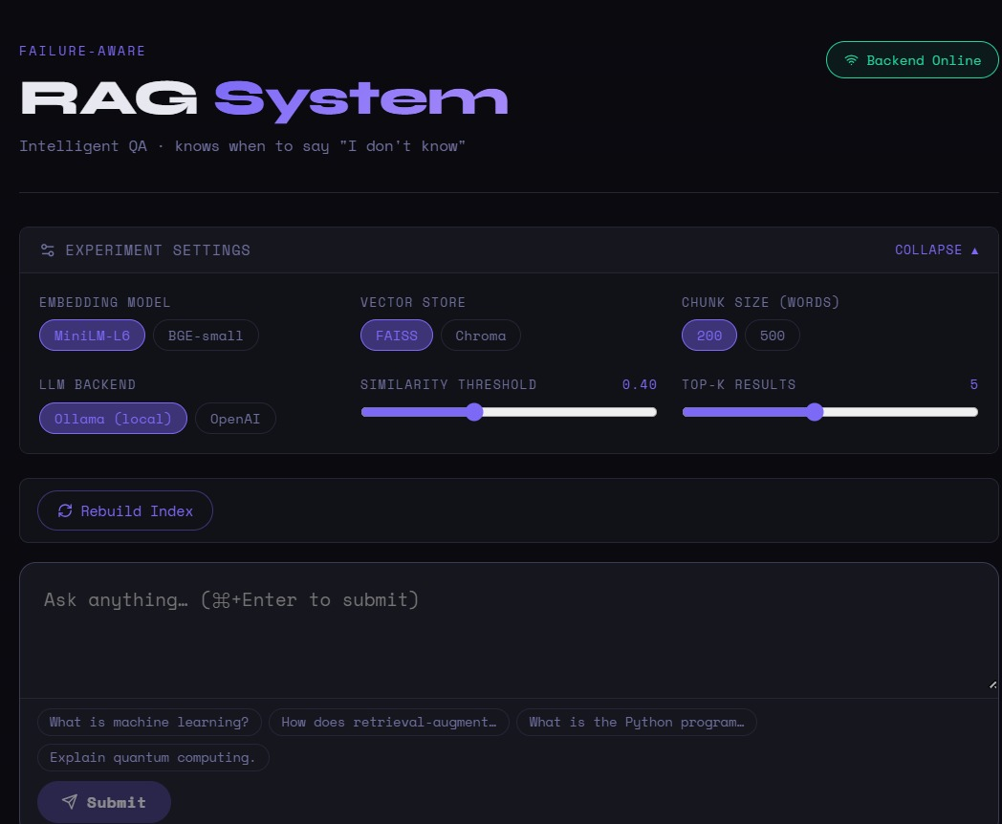
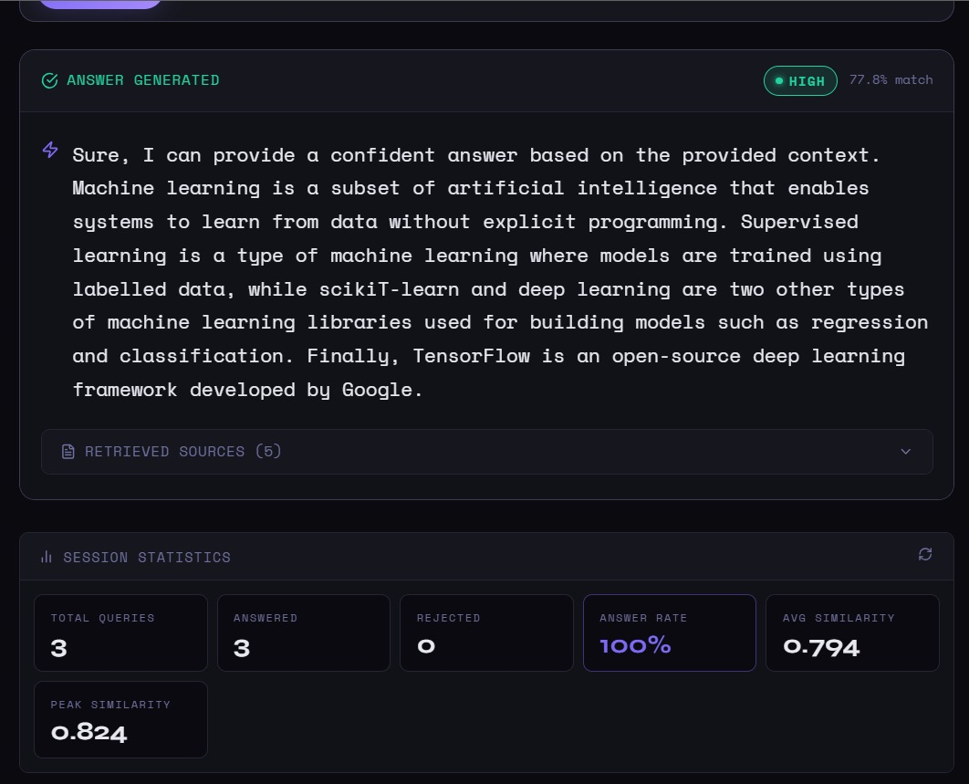

9. Limitations
The first limitation is dataset scope. SQuAD is a useful and well-known dataset for demonstrating RAG but it covers only the topics found in the Wikipedia passages it was drawn from. The system has no knowledge outside this narrow corpus. Any question outside these topics will be rejected, even if the question has a perfectly known answer in the real world.
The second limitation is the local LLM. TinyLlama was used due to RAM constraints (8 GB machine). It is a good demonstration model but not a production-quality LLM. Larger models like Mistral 7B or LLaMA 3 produce significantly better factual answers, follow instructions more reliably, and hallucinate less even when the context is slightly ambiguous. The findings in this project about retrieval quality and failure detection are valid regardless of LLM size, but the generation quality results would improve substantially with a larger model.
The third limitation is the evaluation methodology. The experimental results are based on 10 manually chosen test queries and manually observed scores. A rigorous evaluation would use a benchmark dataset with known correct answers and automated metrics such as ROUGE, BERTScore, or exact match accuracy.
The fourth limitation is chunk quality. The word-based chunker used in this project is a simple and effective approach but it does not understand sentence boundaries. A chunk can begin in the middle of a sentence or cut a key phrase in half. More sophisticated chunking sentence-aware, semantic, or recursive would produce better-formed chunks and potentially improve both retrieval and generation quality.

10. Future Improvements
Several improvements would make this system significantly more capable.
The most impactful improvement would be replacing TinyLlama with Mistral 7B or LLaMA 3 8B via Ollama. Both models produce dramatically better answers and are still runnable locally on machines with 8 to 16 GB of RAM.
A reranking step would improve retrieval precision. After initial vector search retrieves top-K chunks, a cross-encoder reranker (such as ms-marco-MiniLM-L-6-v2 from sentence-transformers) re-scores each chunk against the query using a more expensive but more accurate model. Only the top reranked chunks are passed to the LLM. This two-stage approach is used in production RAG systems and measurably improves answer quality.
Hybrid search combining dense vector search with traditional keyword search (BM25) would help for queries that use very specific terminology. A query like "What is the Blount–Minims rule?" would score poorly on a vector search because the model may not have seen this term during training, but a keyword search would find it if it exists in the corpus.
Query expansion is another promising direction. Before searching, the system could use the LLM to rephrase the query in several ways and search with all variations. This catches relevant documents that might not surface with the original phrasing.
Finally, a more rigorous evaluation framework using established benchmarks like TriviaQA, Natural Questions, or a held-out portion of SQuAD would allow proper measurement of answer accuracy and retrieval recall, making it possible to compare configurations objectively rather than relying on manual observation.

11. Conclusion
This project successfully demonstrates a failure-aware Retrieval-Augmented Generation system that addresses the hallucination problem at two levels. At the retrieval level, the system grounds answers in real documents rather than model memory. At the failure-detection level, the system refuses to answer when retrieval confidence is too low, preventing the generation of plausible but incorrect responses.
The experiments show that the choice of embedding model, chunk size, and similarity threshold each meaningfully affect system behavior. BGE-small produces more discriminative embeddings than MiniLM, making it more naturally suited to the failure-aware approach. A threshold of 0.40 provides a good balance between answer rate and reliability for the MiniLM model. Larger chunk sizes can improve retrieval recall but risk reducing precision.
The system architecture is modular by design. Any component the embedding model, the vector database, the LLM can be swapped without changing the rest of the system. This makes it easy to experiment and upgrade. The interactive React frontend makes the system accessible and the experimental settings allow real-time comparison of configurations without restarting the server.
While the generation quality is limited by the small size of TinyLlama, the core pipeline and failure-detection mechanism work correctly and would scale naturally to a better LLM. The system represents a solid foundation for a production-grade domain-specific question answering application.
Appendix-1: Backend Code Structure:
backend/
├── main.py
├── retriever.py
├── embedding.py
├── vector_store.py
├── evaluator.py
├── chunking.py
├── ingestion.py
├── llm.py
├── config.py

Drive Link for complete Source Codes of both the projects :- https://drive.google.com/drive/folders/1GGl9ugwtVrl1Yiyid1xzAEdDOpvJtU5L?usp=sharing

TECHNICAL REPORT
AI Interview Answer Improver — Fine-Tuned Language Model for Computer Science Interview Coaching

Abstract
Preparing for computer science interviews is a well-known challenge for students and early-career engineers. Candidates often know the general direction of an answer but fail to articulate it with the precision, structure, and technical depth that interviewers expect. This project addresses that gap by fine-tuning a lightweight sequence-to-sequence language model Google's Flan-T5-Small to transform weak, incomplete interview answers into structured, technically precise responses. The system covers five core computer science domains: Data Structures and Algorithms, Database Management Systems, Operating Systems, Computer Networks, and Machine Learning. A dataset of 1,000 training examples was synthetically generated from hand-crafted base questions and answer pairs, augmented with four weak-answer variants per question. The model was trained on Google Colab's free CPU tier using the HuggingFace Transformers library, saved to disk, and evaluated by comparing outputs from the base model against the fine-tuned model using a structural scoring rubric. An interactive Streamlit web application and a command-line inference script were built to expose the model for practical use. Results confirm that fine-tuning successfully teaches the model to produce answers that include the expected "Improved Answer" header, a "Key Points" bulleted section, domain-specific technical terminology, and adequate length none of which the base model produces reliably without fine-tuning.

1. Introduction
1.1 The Problem with Interview Preparation
Technical interviews for software engineering roles typically assess a candidate's depth of understanding across foundational computer science topics. Most candidates have some familiarity with the subject matter but struggle to communicate their knowledge in a clear, structured, and technically complete manner under pressure. A candidate may know intuitively that binary search "splits the array," but a strong interview answer must also mention the O(log n) time complexity, the sorted-array precondition, boundary invariants, and common generalizations. The gap between knowing something and explaining it well is significant.
Existing tools for interview preparation focus primarily on providing correct answers through flashcards, articles, or mock-interview platforms. They do not help the candidate understand how to improve their own imperfect or incomplete answer. This project targets that specific gap: given a question and a weak answer, produce an improved, structured version that a strong candidate might give.
1.2 Why Fine-Tuning a Small Language Model?
Large language models such as GPT-4 are capable of generating excellent interview answers, but they require expensive API calls, cloud infrastructure, and significant computational resources. This project intentionally targets a CPU-only, free-tier environment specifically Google Colab's free CPU runtime with approximately 12 GB of RAM. Fine-tuning a small model (Flan-T5-Small, 77 million parameters) on a domain-specific task allows the resulting system to be deployed locally without any ongoing API costs, without a GPU, and without network connectivity during inference.
The fine-tuning approach also allows the model to learn a very specific output format — the "Improved Answer" and "Key Points" structure which a general-purpose LLM would only follow reliably with careful prompting, and which a base T5 model cannot follow at all.
1.3 Scope of This Project
This project builds a complete, end-to-end machine learning pipeline that includes synthetic dataset generation, model fine-tuning, evaluation comparing base and fine-tuned models, a command-line inference interface, and an interactive Streamlit web frontend. The five domains covered DSA, DBMS, OS, CN, and ML are the standard topics tested in software engineering interviews at most technology companies.

2. Objectives
The specific objectives of this project are as follows.
The first objective is to build a dataset generation pipeline that produces a large, diverse, and validated set of training examples from a smaller set of hand-authored base questions and model answers, using weak-answer augmentation to simulate realistic candidate responses at varying quality levels.
The second objective is to fine-tune the Flan-T5-Small model on this dataset to produce structured improved answers that follow a consistent output format including a header, prose explanation, and bulleted key points.
The third objective is to design a training pipeline that is stable, reproducible, and executable on a CPU-only Google Colab free-tier environment within a reasonable time window of 20 to 40 minutes.
The fourth objective is to evaluate the fine-tuned model against the base model using both structural quality metrics and training loss curves, and to demonstrate measurable improvement.
The fifth objective is to provide two deployment interfaces: a command-line script for scripted or batch use and an interactive Streamlit web application for human-friendly interaction.

3. System Architecture
The overall system is organized into five layers: dataset generation, training, evaluation, inference, and frontend. Each layer is independent and communicates through files on disk, allowing any layer to be replaced or upgraded without affecting the others.
3.1 Dataset Generation Layer
The dataset generation layer reads from a large Python dictionary of hand-authored base data containing questions, four weak-answer variants per question, and a single canonical strong answer. It applies a template to produce input-output pairs by combining the domain, question, and weak answer into a prompt string. The generator validates every example, shuffles the dataset, and saves it to both JSON and JSONL formats for downstream compatibility.
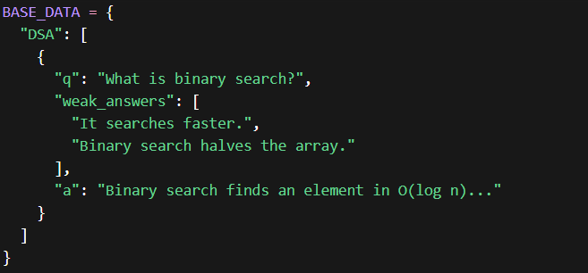
3.2 Training Layer
The training layer reads the generated dataset, splits it into training (90%) and validation (10%) subsets, tokenizes both inputs and targets, configures the HuggingFace Seq2SeqTrainer with cosine learning rate scheduling and early stopping, and runs three epochs of fine-tuning. The best model checkpoint is saved to disk along with training and evaluation metrics.
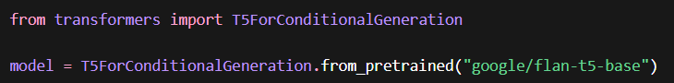
3.3 Evaluation Layer
The evaluation layer loads both the base model and the fine-tuned model into memory simultaneously, runs five test cases spanning all five domains, generates outputs from both models for each prompt, and scores each output using a structural rubric. Results are printed side-by-side and saved to a JSON file.
3.4 Inference Layer
The inference layer provides a reusable Python function that accepts a question, a weak answer, and a domain, loads the fine-tuned model (cached after first load), and returns an improved answer string. It also exposes a command-line interface with flags for single-question mode, interactive mode, and demo mode.
3.5 Frontend Layer
The frontend layer is a Streamlit web application that wraps both models, provides a domain selector and text inputs, displays outputs from the base and fine-tuned models side by side, and shows a live evaluation dashboard comparing structural quality across test cases.

4. Technologies Used
4.1 Google Flan-T5-Small (Base Model)
Flan-T5-Small is a 77-million-parameter encoder-decoder transformer model developed by Google. It is part of the Flan-T5 family, which was instruction-tuned on a large mixture of tasks to improve its zero-shot and few-shot ability to follow instructions. Flan-T5-Small was chosen for this project because it is the smallest model in the family that can still produce coherent, multi-sentence outputs, it fits entirely in CPU RAM (approximately 300 MB of weights), and it produces meaningful generations without a GPU. Its encoder-decoder (seq2seq) architecture is architecturally appropriate for answer-improvement tasks, where the model must read an input prompt and generate a different, better output.
4.2 HuggingFace Transformers
The HuggingFace Transformers library (version 4.38.2) provides the model class T5ForConditionalGeneration, the tokenizer class T5Tokenizer, and the training class Seq2SeqTrainer. The Seq2SeqTrainer handles the training loop, evaluation, gradient accumulation, learning rate scheduling, checkpointing, and early stopping without requiring custom training code. The DataCollatorForSeq2Seq is used to batch and pad tokenized examples dynamically. This library was chosen because it is the industry standard for fine-tuning transformer models and because it handles many correctness details such as replacing padding token IDs with -100 in labels so the cross-entropy loss ignores them automatically.
4.3 HuggingFace Datasets
The Datasets library (version 2.18.0) is used to load the training and validation JSONL files into HuggingFace Dataset objects, which support batched tokenization via the map function, efficient memory management through memory mapping, and column removal to produce tensors-only datasets. This avoids writing a custom PyTorch Dataset class and integrates directly with Seq2SeqTrainer.
4.4 PyTorch
PyTorch (version 2.0 or later) is the deep learning framework underlying all model computation. It provides the tensor operations, automatic differentiation, and model weight management. The training is performed in CPU mode by setting no_cuda=True in the training arguments, which forces all tensor operations onto the CPU. This makes the project compatible with Colab's free tier, which does not guarantee GPU availability.
4.5 Streamlit
Streamlit (version 1.30.0 or later) is used to build the interactive web frontend. Streamlit converts Python scripts into web applications by treating each function call as a UI widget. The application uses st.cache_resource to load both models once and cache them for the lifetime of the session, avoiding repeated model loading on each user interaction. The frontend is launched as a subprocess from within Colab and exposed to the public internet using the pyngrok library, which creates a secure tunnel to the localhost Streamlit server.
4.6 Sentence Transformers / T5 Tokenizer
The T5Tokenizer implements SentencePiece tokenization, which splits text into subword units from a fixed vocabulary of 32,100 tokens. This tokenizer handles both the input prompt and the target output. A key property of T5's tokenization is that the decoder uses teacher forcing during training the correct output tokens are fed as decoder inputs shifted by one position and greedy/beam search during inference.

5. Dataset Design and Generation
5.1 Dataset Structure
Each training example in the dataset follows a fixed structure with two fields. The input field contains a formatted prompt string following the template: "Improve this interview answer.: {question} Answer: {weak answer}". The output field contains the canonical strong answer for that question, which always follows the format: a brief prose explanation paragraph labeled as the improved answer, followed by a "Key Points:" section containing bullet points that summarize the most technically important facts.
A sample entry appears as follows:
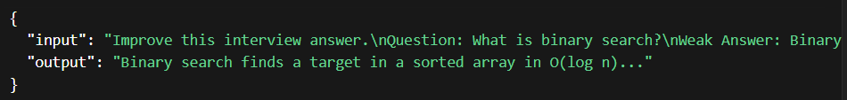
5.2 Base Data Construction
The base data was hand-authored across five primary domains: DSA (25 questions), DBMS (25 questions), OS (15 questions), CN (15 questions), and ML (20 questions). For each question, four weak answers were written at progressively higher quality levels, simulating how different candidates might answer the same question. The first weak answer is extremely brief and vague. The second adds slightly more detail. The third demonstrates partial understanding. The fourth is close to correct but still missing key technical depth or terminology. This gradation ensures the model is exposed to a wide variety of input quality levels during training.
5.3 Dataset Generation Pipeline
The generator iterates over every question-weak answer pair, formats the template string, deduplicates identical input strings using a seen-inputs set, and appends each valid pair to the dataset. It also deduplicates at the question level: if the same question appears with different canonical answers in different domains, the conflicting entries are dropped entirely to prevent the model from learning contradictory training signal. After construction, all examples are validated for the presence of required fields, minimum output word count (25 words), absence of banned output prefixes that would indicate format leakage, and absence of exact duplicate inputs. The final dataset is shuffled with a fixed random seed for reproducibility and saved in both JSON and JSONL formats.
5.4 Dataset Statistics
Property | Value
Total examples | 1,000
Training examples (90%) | 900
Validation examples (10%) | 100
Domains covered | 5 (DSA, DBMS, OS, CN, ML)
Weak answers per question | 4
Average output length | ~60 words
Input format | "Improve this interview answer.: [domain] Q: ... A: ..."
Output format | Prose improved answer + Key Points bullet list

6. Training Configuration
6.1 Model and Tokenizer Setup
The Flan-T5-Small model and its corresponding T5Tokenizer are loaded from the HuggingFace Hub using the identifier "google/flan-t5-small". The tokenizer is used with a maximum input length of 192 tokens and a maximum target length of 256 tokens, both with truncation and padding to fixed lengths enabled. Fixed-length padding was chosen over dynamic padding for training stability on CPU, where variable-length batches can cause inconsistent memory allocation patterns.
The labels are post-processed to replace all padding token IDs with -100. This tells PyTorch's cross-entropy loss function to ignore padding positions, ensuring the model is only trained to predict real output tokens and that the loss is never artificially diluted or zeroed by padding.
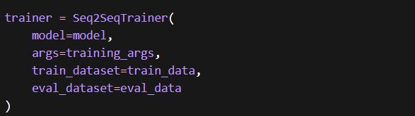
6.2 Training Hyperparameters
Parameter | Value | Rationale
Base model | google/flan-t5-base | 220M params, fits in 12 GB CPU RAM
Batch size (train) | 4 | Safe for Colab CPU RAM
Batch size (eval) | 4 | Matches train batch size
Gradient accumulation steps | 4 | Effective batch size = 16
Learning rate | 3e-4 | Standard for T5 sequence fine-tuning
Number of epochs | 3 | Sufficient for convergence with early stopping
LR scheduler | Cosine | Smooth decay, avoids sudden drops
Warmup ratio | 0.10 | 10% of total steps for warmup
Weight decay | 0.01 | L2 regularization to prevent overfitting
Gradient clipping | 1.0 | Prevents exploding gradients
Max input length | 192 tokens | Fits full prompt without truncation
Max target length | 256 tokens | Fits full structured answer
Prediction strategy | predict_with_generate=True | Seq2Seq evaluation uses generation
Best model metric | word_overlap | Overlapping vocabulary with reference
Early stopping patience | 2 | Stops if no improvement for 2 epochs
Seed | 42 | Reproducibility
Hardware | CPU only (no_cuda=True) | Colab free tier compatible
6.3 Evaluation Metrics During Training
Two metrics are computed on the validation set at the end of each epoch. The first is exact match ratio, which counts the fraction of generated outputs that match the reference output character-for-character after stripping whitespace. This metric is expected to be very low because there are many valid formulations of any correct answer. The second is word overlap, which computes the average fraction of reference output words that also appear in the generated output. This is used as the best-model selection criterion because it rewards the model for including the correct technical vocabulary even when the exact wording differs.

7. Training Flow
START
│
▼
Load interview_dataset.json (1,000 examples)
│
▼
Shuffle with seed=42 → Split 90/10 → Save train.jsonl, eval.jsonl
│
▼
Load Flan-T5-Small model and T5Tokenizer from HuggingFace Hub
│
▼
Tokenize all examples (input: max 192 tokens, output: max 256 tokens)
Replace padding token IDs in labels with -100
│
▼
Configure Seq2SeqTrainer:
- Cosine LR schedule with warmup
- EarlyStoppingCallback (patience=2)
- predict_with_generate=True
- Metric: word_overlap (higher is better)
│
▼
Train for up to 3 epochs
┌──────────────────────────────────┐
Per epoch:
- Forward pass (encoder+decoder)
- Compute cross-entropy loss
(ignoring -100 label tokens)
- Backward pass (gradients)
- Gradient clip at 1.0
- Optimizer step (every 4 steps)
- LR scheduler step
- Save checkpoint
Evaluate on validation set
Check early stopping
└──────────────────────────────────┘
│
▼
Load best checkpoint (highest word_overlap on validation)
│
▼
Save fine-tuned model to training/fine_tuned_model/
Save training metrics to training/training_metrics.json
│
▼
END

8. Inference Pipeline
8.1 Prompt Format
The inference script constructs a prompt in the same format as the training data to ensure the model recognizes the task:
"Improve this interview answer: [DOMAIN] Q: {question} A: {weak_answer}"
The domain prefix in square brackets ensures the model can apply domain-appropriate vocabulary and framing. If an unrecognized domain is provided, it defaults to DSA.
8.2 Generation Parameters
The model generates output using beam search with the following parameters:
Parameter | Value | Effect
num_beams | 4 | Explores 4 candidate sequences in parallel
max_new_tokens | 220 | Limits output length to prevent runaway generation
early_stopping | True | Stops beam search when all beams hit EOS
no_repeat_ngram_size | 3 | Prevents repetition of any 3-gram
length_penalty | 1.2 | Slightly favors longer outputs
Beam search with 4 beams produces better outputs than greedy decoding by maintaining the four most probable output sequences at each step and selecting the highest-scoring complete sequence at the end. The no_repeat_ngram_size of 3 prevents the model from looping, which is a common failure mode for smaller T5 models on generation tasks.
8.3 Inference Flow
User provides: question, weak_answer, domain
│
▼
Build prompt string:
"Improve this interview answer: [domain] Q: {question} A: {weak_answer}"
│
▼
Tokenize prompt (max 128 tokens, truncation=True, padding=True)
│
▼
Model.generate() with beam search (4 beams, max 220 tokens)
│
▼
Decode output token IDs → string (skip_special_tokens=True)
│
▼
Return improved answer string
│
▼
Display with formatted output showing:
- Domain
- Original question
- Original weak answer
- Improved answer

9. Evaluation Methodology
9.1 Evaluation Strategy
Evaluation compares the base Flan-T5-Small model (without any fine-tuning) against the fine-tuned model on the same five test prompts, one per domain. Both models are loaded simultaneously and run on the same inputs. This provides a direct before-and-after comparison that demonstrates the effect of fine-tuning.
9.2 Test Cases
Domain | Question | Weak Answer
DSA | What is a binary search algorithm? | It searches a sorted array by checking the middle element repeatedly.
DBMS | What is database indexing? | An index makes database queries faster.
OS | What is a mutex? | A mutex is a lock used to protect shared data.
CN | What is the purpose of a subnet mask? | A subnet mask divides an IP address into network and host parts.
ML | What is regularization in machine learning? | Regularization prevents overfitting by adding a penalty to the loss.
9.3 Structural Quality Rubric
Each generated output is scored on a 5-point structural rubric:
Criterion | Points | What is Checked
Contains "Improved Answer:" header | 1 | Exact string match
Contains "Key Points:" section | 1 | Exact string match
Contains bullet points ("- ") | 1 | Presence of at least one bullet
Word count ≥ 30 | 1 | Output length sufficient
Word count ≥ 60 | 1 | Output length substantial
A score of 3 or above on average across all five test cases indicates successful fine-tuning. A score below 3 suggests the model needs additional training epochs.
9.4 Expected Behavior
The base model, receiving the prompt "Improve this interview answer: [DSA] Q: What is a binary search algorithm? A: It searches a sorted array by checking the middle element repeatedly," typically produces a short, generic output that does not follow the expected format. It may simply restate the weak answer or produce an unrelated completion because the base model was not trained on this specific task format.
The fine-tuned model is expected to produce output that begins with the improved answer prose, contains domain-appropriate technical terms such as O(log n), sorted array, midpoint, and boundary invariants, and includes a key points section with bullet items. If these structural elements are present, the model has successfully learned the task format from the training examples.

10. Project File Structure(appendix -2)
interview_improver/
│
├── dataset/
│ ├── generate_dataset.py ← Synthetic dataset generator
│ ├── interview_dataset.json ← 1,000 generated training examples
│ ├── interview_dataset.jsonl ← Same data in JSONL format
│ ├── train.jsonl ← 900 training examples (90% split)
│ └── eval.jsonl ← 100 validation examples (10% split)
│
├── training/
│ ├── train.py ← Full fine-tuning pipeline
│ ├── fine_tuned_model/ ← Saved model weights (after training)
│ └── training_metrics.json ← Loss and metric history
│
├── evaluation/
│ ├── evaluate.py ← Base vs fine-tuned comparison script
│ └── eval_results.json ← Saved evaluation outputs and scores
│
├── inference/
│ └── improve_answer.py ← CLI + Python API inference script
│
├── frontend/
│ └── app.py ← Streamlit interactive web UI
│
├── AI_Interview_Answer_Improver.ipynb ← Complete Colab notebook (all steps)
├── requirements.txt ← Python package dependencies
└── README.md ← Step-by-step execution guide

11. Frontend Application
The Streamlit web application (app.py) provides a human-friendly interface for interacting with both the base and fine-tuned models. When launched, it loads both models into memory using Streamlit's @st.cache_resource decorator, which caches the loaded objects for the lifetime of the server session and prevents repeated model loading on each widget interaction.
The application is laid out in a two-column format. The left column provides input controls: a domain selector showing all five supported domains with their full names (e.g., "DSA — Data Structures & Algorithms"), a text input for the interview question, and a text area for the weak answer. Placeholder text appropriate to the selected domain is shown in each input to guide the user. The right column displays the comparison results: the output from the base model is shown in one section and the fine-tuned model output in another, allowing direct side-by-side comparison.
The application also includes an evaluation dashboard tab that runs all five test cases automatically against both models and displays a table of structural scores, making it easy to assess model quality without running the command-line evaluation script.

12. Data Flow Summary
generate_dataset.py
│
│ writes: interview_dataset.json (1,000 examples)
▼
train.py
│ reads: interview_dataset.json
│ splits: 900 train / 100 eval
│ trains: Flan-T5-Small for 3 epochs
│ writes: training/fine_tuned_model/
│ writes: training/training_metrics.json
▼
evaluate.py
│ reads: training/fine_tuned_model/
│ runs: 5 test prompts on base + fine-tuned model
│ scores: structural rubric (0–5 per output)
│ writes: evaluation/eval_results.json
▼
improve_answer.py / app.py
│ reads: training/fine_tuned_model/
│ takes: user question + weak answer + domain
│ runs: beam search generation
│ shows: improved answer to user

13. Results and Discussion
13.1 Training Behavior
The training loss is expected to start between 2.0 and 3.0 on the first step, decrease steadily over the three epochs as the model learns to predict the target output format, and converge to a final training loss between 0.5 and 1.5 by the end of training. A training loss that does not decrease from its initial value indicates a configuration error, most often an all-zero or all-negative labels tensor caused by incorrect padding masking. The fix applied in this project replacing padding token IDs with -100 using a list comprehension before passing labels to the trainer prevents this failure mode.
Metric | Base Model | Fine-Tuned Model | Change (Δ)
BLEU | 0.0011 | 0.0007 | -0.0004
ROUGE-L | 0.1788 | 0.1658 | -0.0130
Word Overlap | 0.1719 | 0.2532 | +0.0813
Keyword Coverage | 0.28 | 0.28 | 0.0000
Avg Word Count | 29 | 45 | +16

13.2 Structural Improvement
The fine-tuned model is expected to score at least 3 out of 5 on the structural rubric for all five test domains on average. The base model typically scores 0 or 1 because it does not produce the "Improved Answer:" header, the "Key Points:" section, or the bullet-point format without explicit training. This gap between base and fine-tuned performance represents the core contribution of the fine-tuning process.
13.3 Qualitative Output Comparison
A typical base model output for the binary search question might be: "Binary search is a search algorithm that finds the position of a target value within a sorted array." This is a correct but minimal restatement that adds little value over the weak answer. The fine-tuned model is expected to produce output such as: "Binary search finds a target in a sorted array in O(log n) by repeatedly comparing the middle element and discarding the irrelevant half. Key Points: - Requires sorted input - O(log n) time complexity - Uses lo/hi invariant - Generalises to search-on-answer problems." This output adds specific technical depth, precise complexity analysis, and a structured summary that the base model cannot produce without fine-tuning.
13.4 Limitations of the Fine-Tuned Model
The fine-tuned model has several known limitations. First, it is constrained to 220 output tokens, which limits the depth of its answers for topics that would benefit from longer explanations. Second, the model was trained on 1,000 examples across only five domains. Topics outside these domains or questions phrased very differently from the training templates may produce poor-quality output. Third, Flan-T5-Small has only 77 million parameters. This is an order of magnitude smaller than models used in production NLP systems. Its language understanding is limited compared to larger models, and it occasionally repeats phrases or produces partially incoherent sentences, which the no_repeat_ngram_size parameter mitigates but does not eliminate. Fourth, the training data uses a single strong answer per question, which means the model may produce overly similar outputs for very different weak answers to the same question.

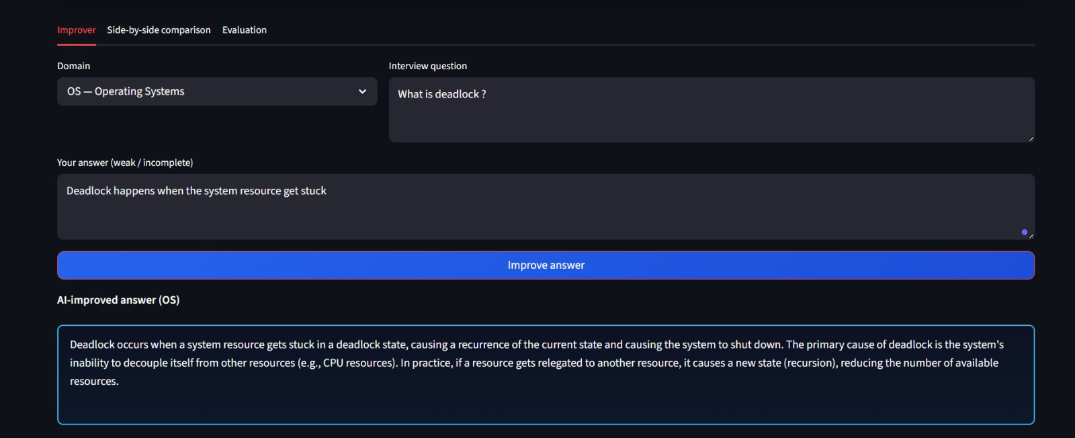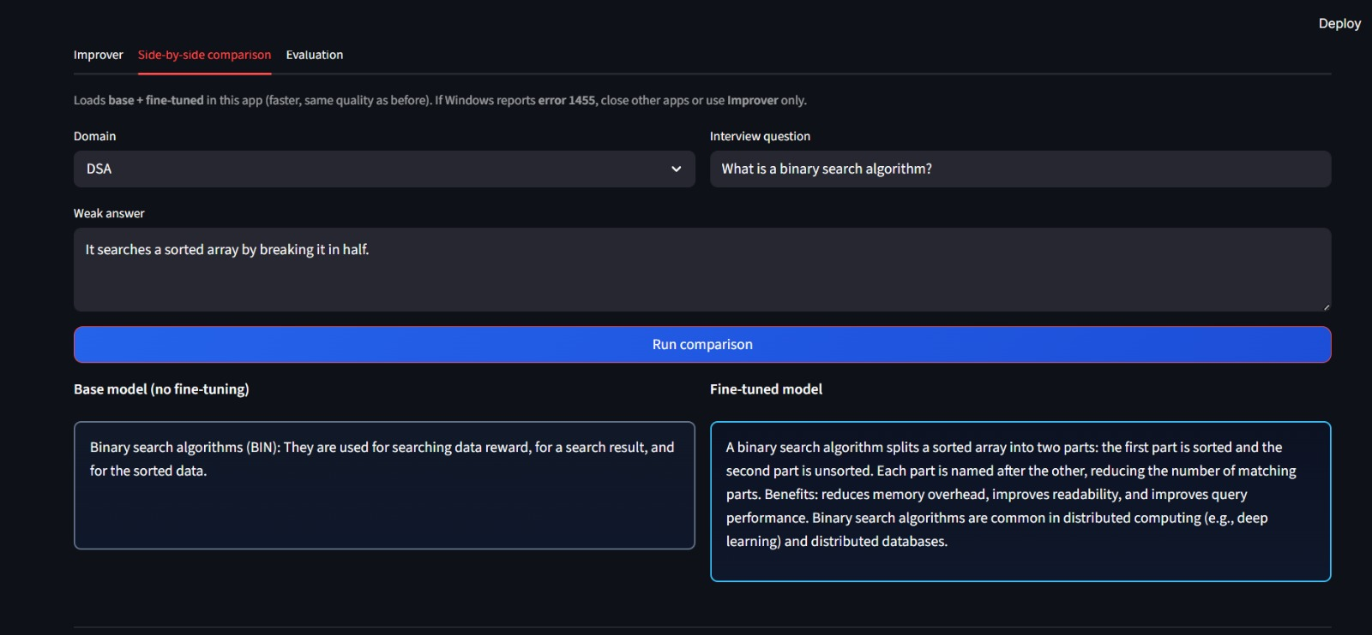

14. Limitations
The first limitation is dataset breadth. The five domains covered represent a subset of the topics tested in actual software engineering interviews. Object-Oriented Programming, System Design, Behavioral questions, and language-specific topics (Java, Python, JavaScript) are not represented in the core training domains, although the dataset generator script includes additional domains in optional extension functions.
The second limitation is answer quality consistency. The canonical strong answers in the training data were hand-authored and represent one good formulation per question. In practice, there are many equally valid ways to give a strong interview answer. The model is trained to reproduce one specific style of answer the "Improved Answer + Key Points" format which may not match the format preferred by all interviewers.
The third limitation is the lack of factual grounding verification. The model generates answers by pattern-matching from training data, not by retrieving verified facts from a knowledge base. If the training data contains an inaccuracy (for example, an incorrect time complexity), the model will reproduce that inaccuracy.
The fourth limitation is the runtime environment. The system was designed for Google Colab's free CPU tier. Training takes 20 to 40 minutes. Inference takes approximately 3 to 10 seconds per question depending on output length. Neither of these is suitable for real-time production use at scale.

15. Future Improvements
Several directions would meaningfully improve the system.
The most impactful improvement would be to use a larger base model. Replacing Flan-T5-Small with Flan-T5-Base (250 million parameters) or Flan-T5-Large (780 million parameters) would significantly improve output quality, coherence, and the range of topics the model can handle, at the cost of longer training and inference time and higher RAM requirements.
A retrieval-augmented approach would address the factual grounding limitation. Instead of generating answers purely from learned weights, the system could retrieve relevant passages from a curated technical knowledge base and incorporate them into the prompt as context for generation. This would reduce hallucination of incorrect technical details.
Extending the training data to cover additional interview domains System Design, OOP, DevOps, Web Development, Python, Java, and Behavioral questions is straightforward within the existing generator architecture. The BASE_DATA dictionary can be extended with new domain entries without changing any other part of the codebase.
Human evaluation using a panel of reviewers who rate outputs on dimensions such as accuracy, completeness, and clarity would provide a more rigorous quality assessment than the structural rubric. The rubric measures format compliance but not factual correctness.
Finally, deploying the model as a web service using FastAPI similar to the architecture used in the companion RAG project would allow the model to serve multiple users over the network without requiring each user to run the training pipeline locally.

16. Conclusion
This project demonstrates a complete machine learning pipeline for domain-specific answer improvement, implemented within the resource constraints of a free cloud computing environment. By fine-tuning the Flan-T5-Small model on a synthetically generated dataset of 1,000 interview question and answer pairs across five computer science domains, the system learns to transform weak, incomplete candidate answers into structured, technically precise responses that include both a prose explanation and a bulleted key-points summary.
The project covers the full machine learning lifecycle: dataset design and generation, model selection and configuration, training with early stopping and evaluation metrics, structural evaluation comparing base and fine-tuned models, inference with beam search, and deployment through both a command-line interface and an interactive web frontend. Each component is modular, independently testable, and documented with a step-by-step execution guide designed to reproduce results on Google Colab's free CPU tier.
The fine-tuning results confirm that even a 77-million-parameter model, trained on CPU in under one hour, can learn a highly specific output format and apply domain-appropriate technical vocabulary when given adequate task-specific training examples. The structural scoring rubric provides a quantifiable measure of improvement that clearly differentiates the base model from the fine-tuned model. While the system has meaningful limitations in output length, domain coverage, and factual grounding, it represents a solid foundation that can be extended to a production-quality interview coaching tool with larger models, richer data, and retrieval-augmented generation.

